Q 1. What’s the benefit of using Spring Boot over Spring? Does it mean we no longer need to know Spring?
- Spring boot extends Spring, so Spring still needful
- Servers are embedded (e.g. Tomcat)
- Spring Boot make the development, testing, and deployment more convenient
- Premade pom.xml file for Maven
- No need XML configuration
Q 2. What’s the difference between CrudRepository and JpaRepository interfaces?
JpaRepository extends PagingAndSortingRepository which in turn extends CrudRepository.
- CrudRepository mainly provides CRUD functions.
- PagingAndSortingRepository provides methods to do numeration and sorting records.
- JpaRepository provides some JPA-related methods such as cleaning the persistence context and deleting records in a package.

Q 3. What’s the point of @SpringBootApplication annotation in Spring Boot projects?
The @SpringBootApplication annotation is equivalent to using @Configuration, @EnableAutoConfiguration, and @ComponentScan with their default attributes

Q 4. What are the bean lifecycles? Explain their associated annotations. - Can you give an example for @PostConstruct usage?
When a bean is instantiated, it may be required to perform some initialization to get it into a usable state. Similarly, when the bean is no longer required and is removed from the container, some cleanup may be required.
Spring calls methods annotated with @PostConstruct only once, just after the initialization of bean properties.
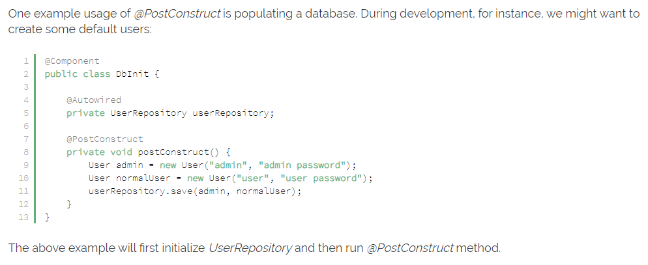

Q 5. Explain the <plugins> attribute in pom.xml file.
Maven is a plugin execution framework where every task is actually done by plugins.
Maven Plugins are generally used to perform commands during project developing.
Q 6. Briefly describe each Maven steps. How we can run a Spring Boot project from command line using Maven?
- Add Spring Boot Plugin to POM.XML
- Build Spring Boot Project with maven = maven package => mvn install
- Run Spring Boot App = mvn spring-boot:run

Q 7. What do we mean by externalizing configuration? Why and When to use application.properties file?
Externalizing configuration = possibility to keep our properties configuration file out of the project, and just set it whey run jar files .
Application.properties is used to keep ‘N’ number of properties for project platform independent external usability (e.g. server.port or spring.application.name)

Q 8. Compare Maven and Gradle build tools. Then, try to replace Maven with Gradle in your solution file for the first chapter. What is Maven/Gradle Wrapper file? How we can execute them?
- Maven is better for small projects, Grable for big and complex ones
- For small projects Maven is better for setting up metadata, with grooving of the project, pom.xml file is grooving as well, and could became unreadable in some moment.
- Maven is better in dependency management and directory structure.
- In Maven there ae more available plugins
- Maven easier combining with third-party tools
- Grable is very flexible, and could be optionally configurated for your needs
- Grable is more powerful
Maven Wrapper is used for setting up specific Maven version, or even avoiding Maven installation.
For using Maven Wrapper:
- Run from the main folder of the project:
mvn -N io.takari:maven:wrapper
- Then we could run our commands, e.g.:
./mvnw clean install
- We could run our Spring-Boot project:
./mvnw spring-boot:run

Q 9. Briefly describe Spring MVC architecture and its components.
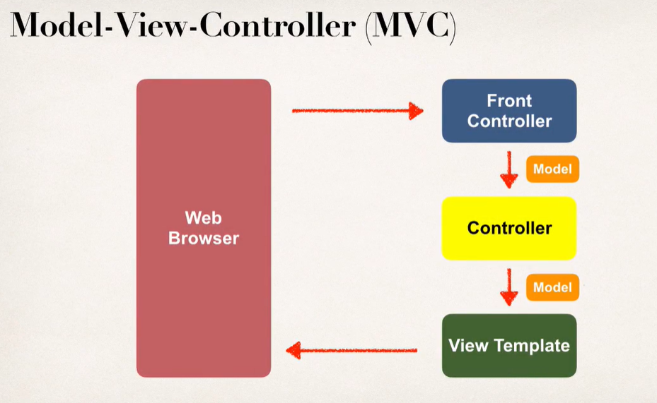

Q 10. What is template in Spring framework? Describe Thymeleaf briefly.
Templates are premade libraries which can be used for avoiding repeatable operations.
Thymeleaf is a Java template engine for processing and creating front-end part.
Library is wide and powerful, so templates could be developed even without back-end.

